**Car Body Damage Detection by using U-Net ++**

**Objective:** We are given a set of images of vehicles. Some of the car are damaged and some are not. Given the image of a car, we need to detect if it is damage or not. We also need to locate and mask this damage and maximize Dice coefficient.

**Keywords:** Imagemask damage, Deep Learning, U-Net plus plus, Image segmentation, Car Body Damage,

**I.Introduction:**  
In used car industry (both marketplace and brick and mortar dealers), apart  
from car’s functionality and equipment availability and healthiness, which only can be accessed by test drive/manual inspection, car body external damages (scratch, dent, repaint, etc.) play a vital role to decide accurate pricing of the vehicle.

In most of the cases, these damages are detected and assessed manually from the car images during the car evaluation process. However, the latest computer vision frameworks can detect the damage location on the car body and help pricers to quantify the damage without much manual intervention.

This concept will also help car insurers in assessing the damage automatically and in processing claims faster. The model can detect the area of damage on a car. The rationale for such a model is that it can be used by insurance companies for faster processing of claims if users can upload pics and they can assess damage from them.

**II.Problem description**  
Developing a deep learning algorithm that can detect car body external damages(scratch, dent, repaint etc.) and help buyer’s to quantify the damage without much manual intervention. This concept will also help car insurers in assessing the damage automatically and in processing claims faster.

**Dice coefficient**

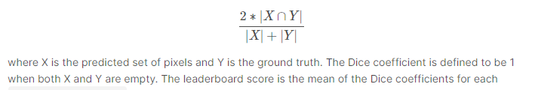

## Metric function: Predictions are evaluated based dice_coefcient

# III. EDA

**1. Collecting Data:**

**2. Annotating the Data:**We need to annotate the images and identify the region of damage.  [VGG Image Annotator](http://www.robots.ox.ac.uk/~vgg/software/via/via-1.0.6.html) annotation tool we will use.

# IV. Data preparation

**tf.data pipeline:** We will use tf.data pipelines for input data preparation, as The tf.data API enables you to build complex input pipelines from simple, reusable pieces since I am planning on small dataset tf data generator will improve the model performance as well as overfitting problems.

**V. Training a Model**

We will use 80% data for training and 20% for validation.

**unet++ model**

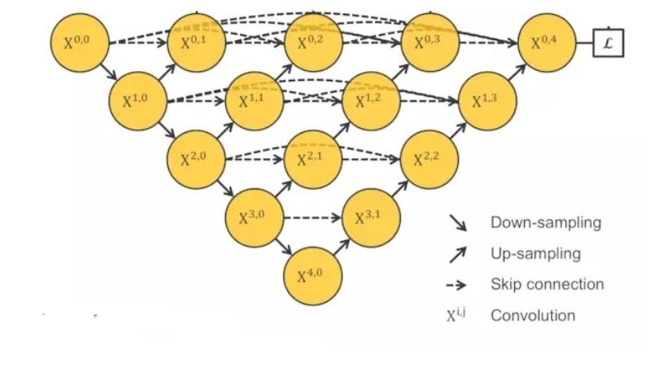

UNet++ is a new general purpose image segmentation architecture for more accurate image segmentation. UNet++ consists of U-Nets of varying depths whose decoders are densely connected at the same resolution via the redesigned skip pathways, which aim to address two key challenges of the U-Net:

1) unknown depth of the optimal architecture and

2) the unnecessarily restrictive design of skip connections.

**VI. Validating the Model**

**VII. Run the Model on Images and Make Predictions**

References:

* <https://www.kaggle.com/c/severstal-steel-defect-detection/overview/evaluation>
* <https://www.programmersought.com/article/23804479329/>
* [U-Net: Convolutional Networks for Biomedical Image Segmentation (uni-freiburg.de)](https://lmb.informatik.uni-freiburg.de/people/ronneber/u-net/)
* [CNN Application-Detecting Car Exterior Damage(full implementable code) | by Sourish Dey | Medium](https://medium.com/@sourish.syntel/cnn-application-detecting-car-exterior-damage-full-implementable-code-1b205e3cb48c)
* [Mask R-CNN | Building Mask R-CNN For Car Damage Detection (analyticsvidhya.com)](https://www.analyticsvidhya.com/blog/2018/07/building-mask-r-cnn-model-detecting-damage-cars-python/)
* <https://medium.com/analytics-vidhya/defect-detection-in-products-using-image-segmentation-a87a8863a9e5>
* https://glassboxmedicine.com/2020/01/21/segmentation-u-net-mask-r-cnn-and-medical-applications/